**Packet Tracer 2 Activity**

***What you will learn in this activity***

* How to select a network device and connect up a network
* How to label a network device
* How to test a network in Realtime mode for connectivity using Pings
* The basic operation of a switch in networking

***Procedure***

1) Double click the packet tracer file “Packet Tracer Switch” to start Packet Tracer with the part-made network containing 4 computers.

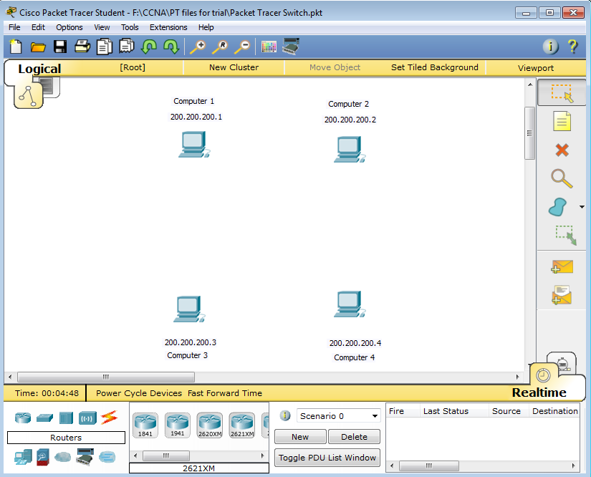

2) Packet Tracer can operate in two modes Realtime(clock ) and Simulation(stopwatch). When you opened the file as shown above Packet Tracer starts in Realtime mode. We will stay in Realtime mode

3) The lower left of the screen gives access to a selection of networking devices and connecting media. Click on the Switches icon (2nd from the top left of the devices). Choose the 2950-24 Switch and click to place in the work space central to the computers. The Switch should now appear ready for use as shown.

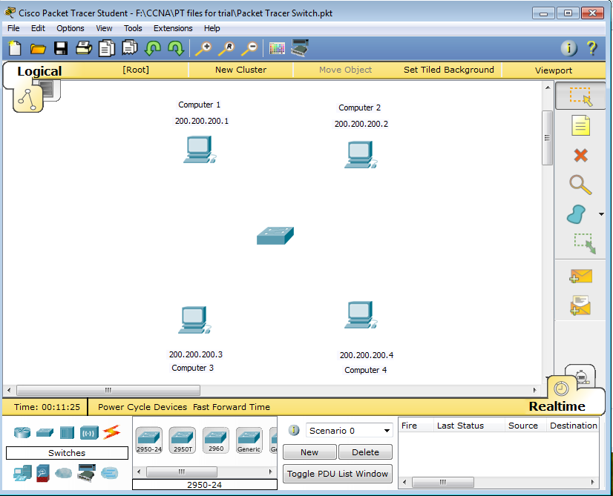

4) Now click on the orange lightning symbol to choose an appropriate connection media. Select Copper Straight-Through and move the mouse cursor to the work space and it changes to a “connector-shape”. Click on Computer 1 and select Fastethernet0, a cable will appear. Now connect the other end by clicking the Switch and selecting Fastethernet0/1. The connection now appears between Computer 1 and the Switch.

5) Repeat step 4 to connect Computer 2 (Fastethernet0) to Switch (Fastethernet0/2). Likewise for Computer 3 and Switch (next Ethernet connection) and Computer 4 and Switch (next Ethernet connection).

6) Click on the note icon on the right side and click in the workspace to enter the label “Switch”. Now click on the top right icon and move the label next to the Switch device. Your network should now look like

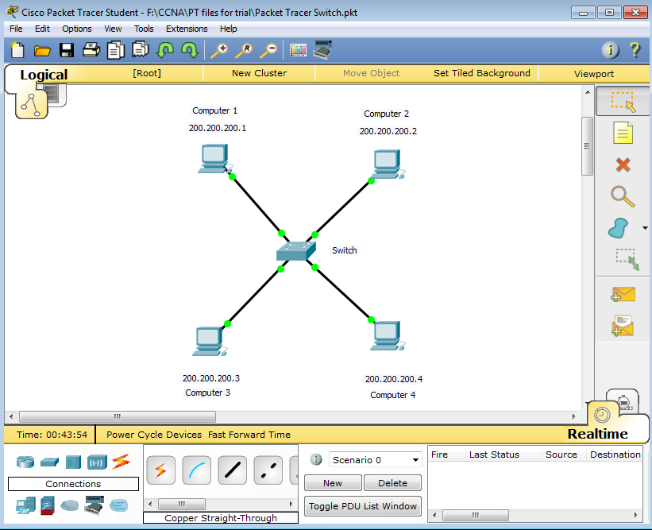

7) We will now test the network for connectivity. Click the icon for Computer 1 then choose the Desktop tab, then Command Prompt. This will open up a command window. Now type Ping 200.200.200.4 and check for a positive echo response

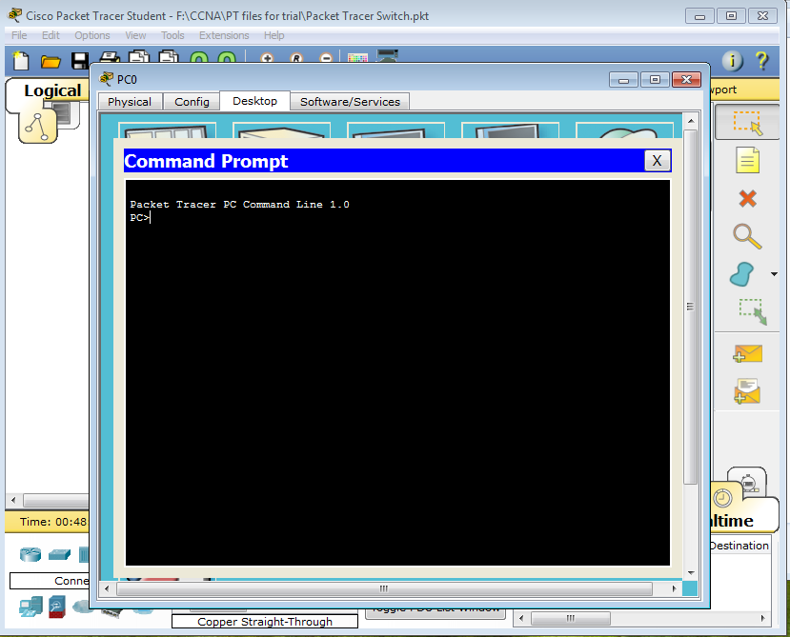

8) Now, in a similar manner, check for connectivity between all of the computers in the network

***Challenge***

Use simulation mode to check the operation of the switch and see what happens to the packet when it reaches the switch

Describe how the operation of a switch is different from a Hub?